**Department of Systemics**

**School of Computer Science**

University of Petroleum and Energy Studies

cid:image003.png@01D81F60.F8BDA810

**ADVANCE DATABASE MANAGEMENT SYSTEM**

**LAB FILE**

Submitted by

**Akshat Negi**

**R2142220414**

**Batch - 2**

B.Tech Computer Science and Engineering(CSF)

Submitted to

**Dr. KOTHA VENUGOPALCHARY**

Assistant Professor (SS)

SOCS, UPES

**LAB EXPERIMENT – 9**

**Aim:** To understand the concepts of implicit and explicit cursor, and Triggers.

**Objective I:** Students will be able to implement the concept of implicit and explicit cursor.

*1. Using an implicit cursor, update the salary by an increase of 10% for all the records in the EMPLOYEES table, and finally display how many records have been updated. If no records exist, display the message “No Change”.*

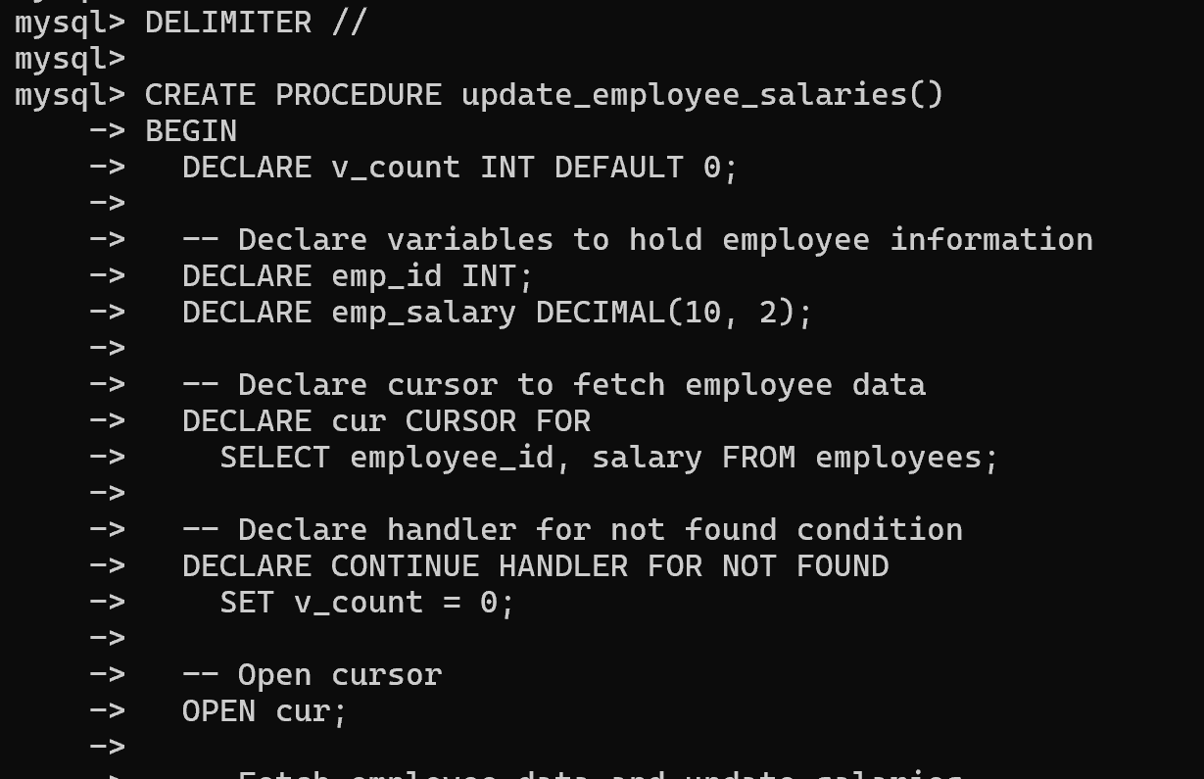

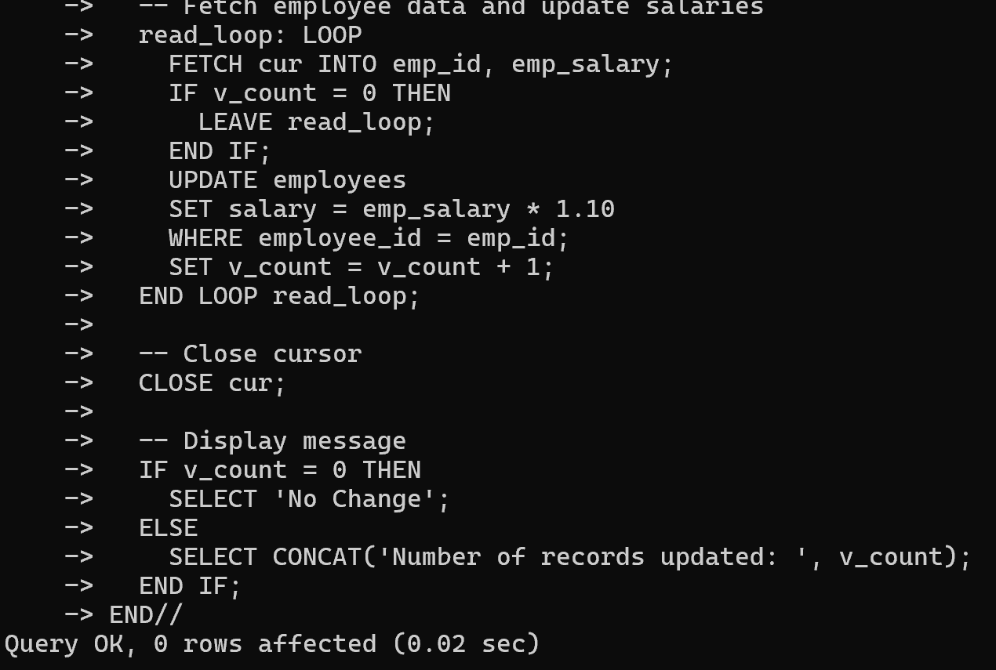

*2. Using an explicit cursor fetch the employee name, employee_id and salary of all the records from the EMPLOYEES table.*

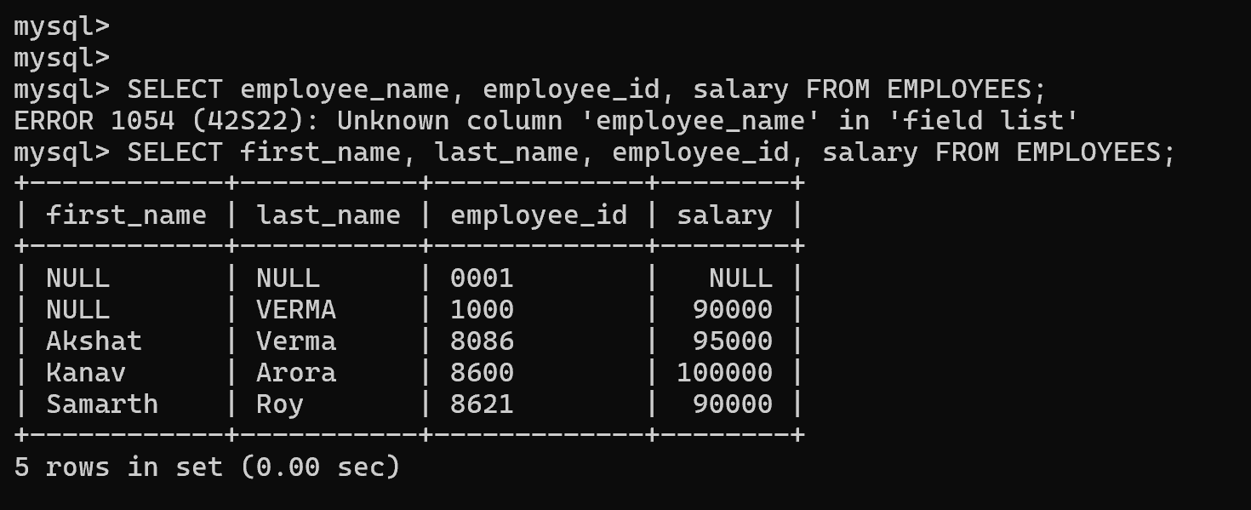

*3. Using an explicit cursor Insert the records from the EMPLOYEES table for the columns employee_id, Last_Name and salary for those records whose salary exceeds 2500 into a new table TEMP_EMP.*

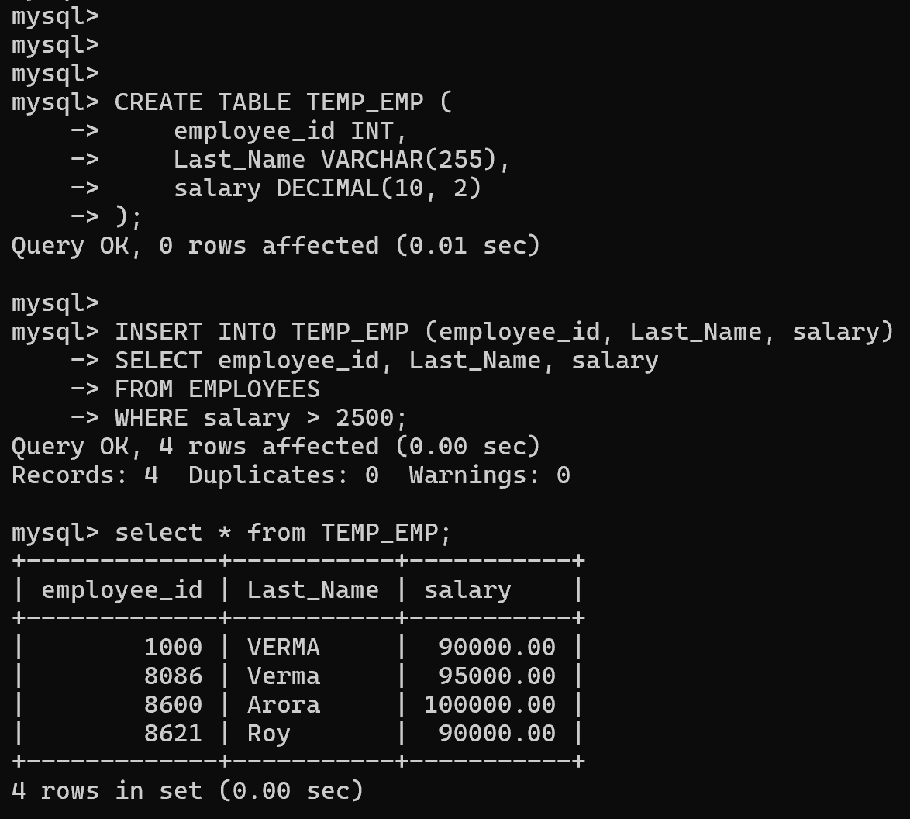

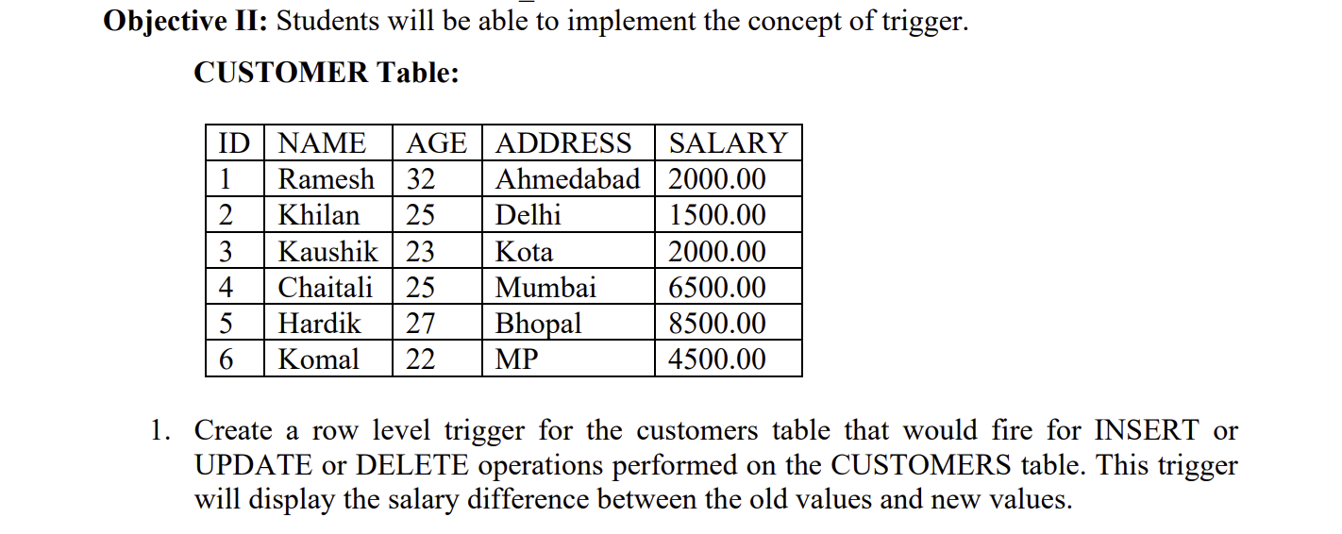

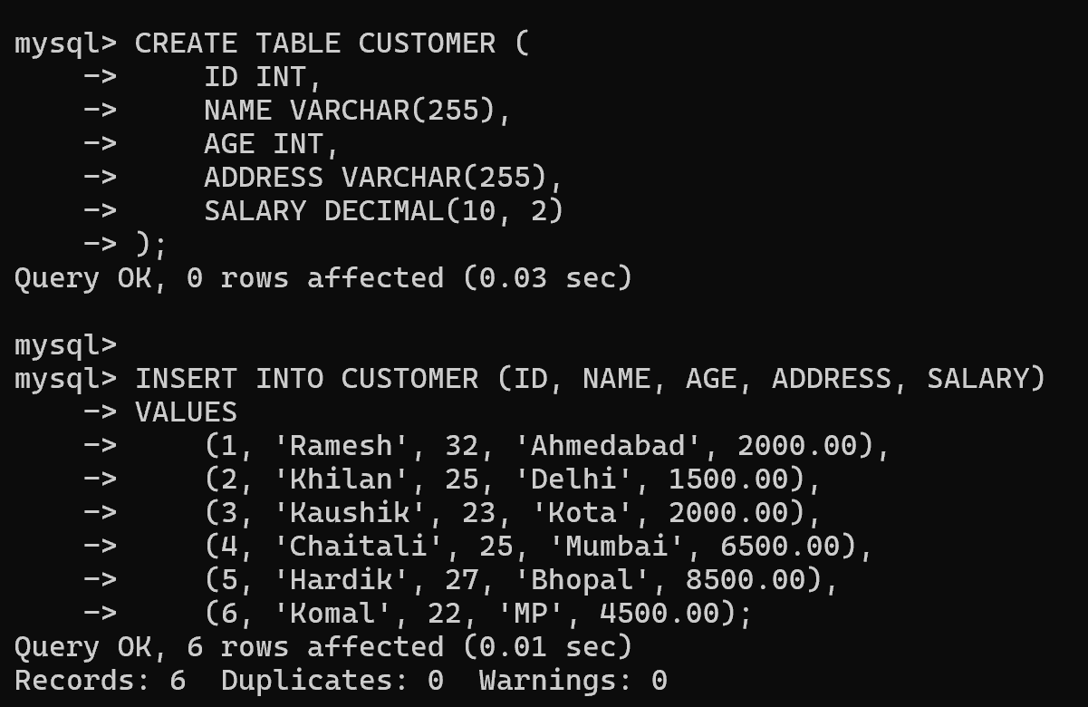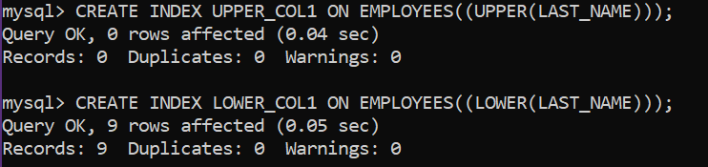

*MySQL does not support creating a trigger for multiple operations (INSERT, UPDATE, DELETE) in a single statement.*

**INSERT.**

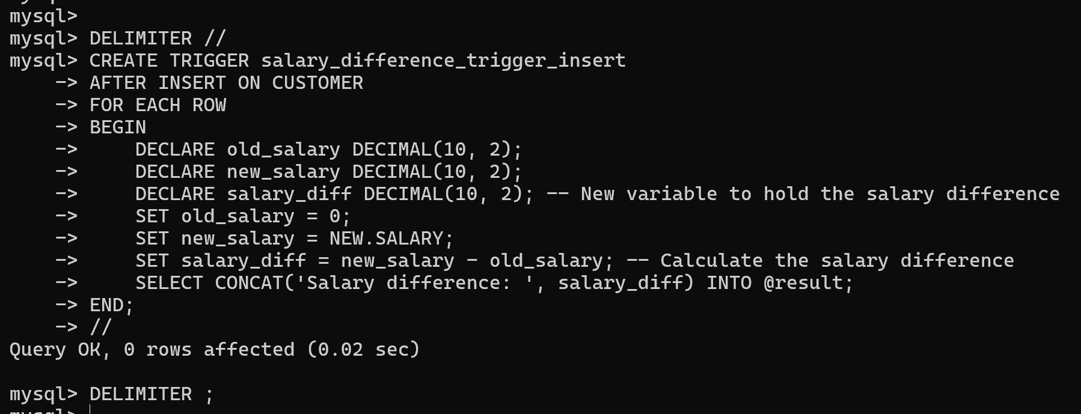

**UPDATE.**

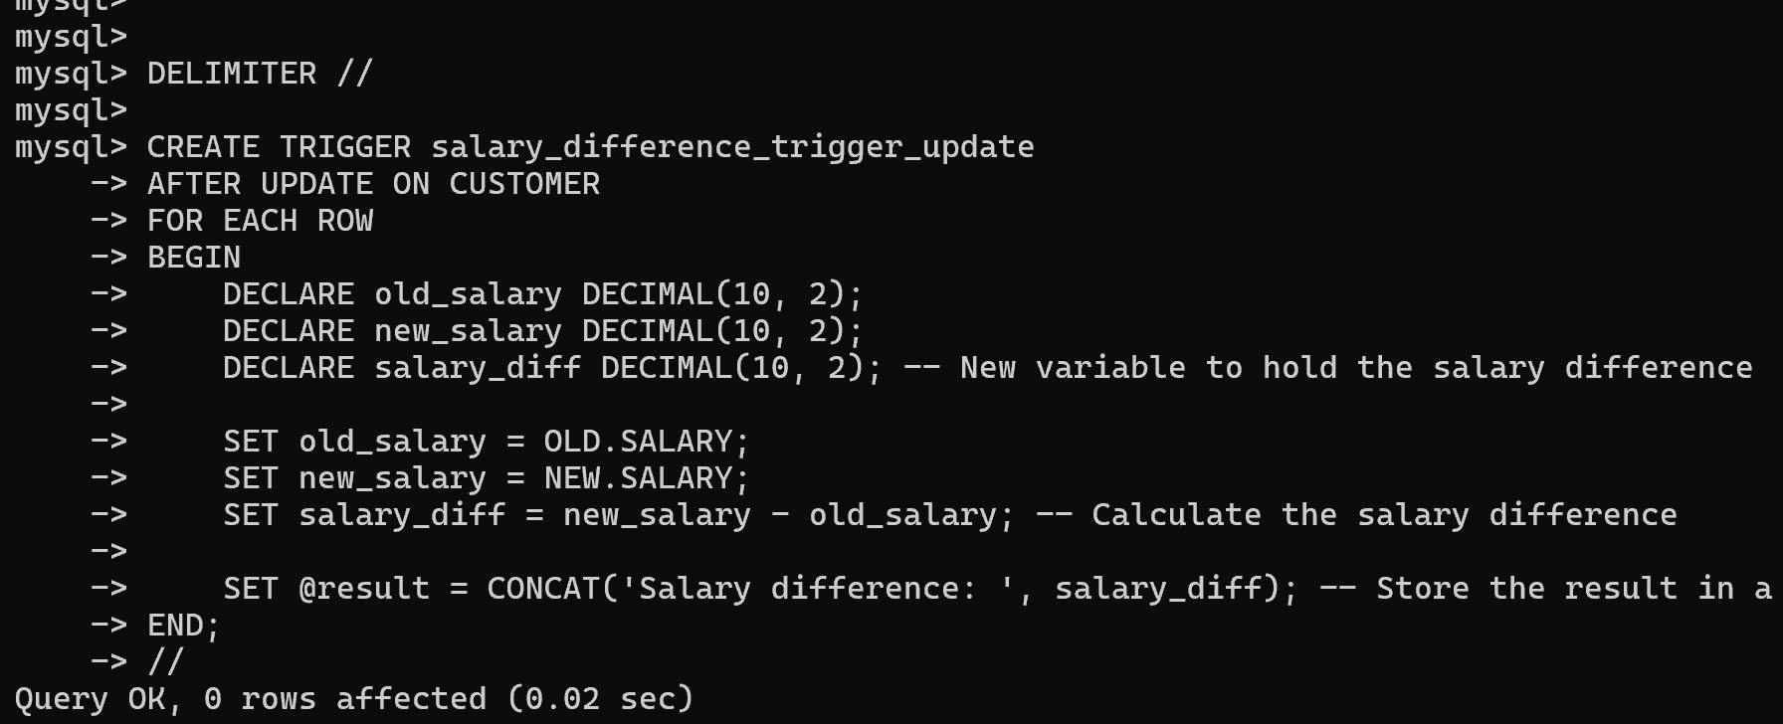

**DELETE.**

